Activity sheet
Aboriginal and Torres Strait Islander peoples – web activity
1. Make a list of what you have learnt about Indigenous issues from your reading of Face the Facts – Questions and Answers about Aboriginal and Torres Strait Islander Peoples:
- some of the important events in Australia’s history in relation to reconciliation including Reconciliation Week and ‘Sorry Day’, the establishment of the Council for Aboriginal Reconciliation and the National Apology
- the history of government policies on Aboriginal and Torres Strait Islander peoples including the separation of Indigenous children from their families, self-determination, and native title
- what a Reconciliation Action Plan is.
....................................................................................................................................................
....................................................................................................................................................
....................................................................................................................................................
....................................................................................................................................................
....................................................................................................................................................
....................................................................................................................................................
....................................................................................................................................................
....................................................................................................................................................
....................................................................................................................................................
2. Working in small groups, take on the role of committee member in the following scenario:
Scenario
You are a member of a committee established to report back on the reconciliation process in Australia to your local council.
1. Identify important events during the reconciliation process at both a local and national level.
2. Plan an event or some other form of celebration to mark the importance of reconciliation between Indigenous and non-Indigenous peoples in your community (use your findings to justify your decisions).
3. Present a short proposal to your local council. Include the background information you identified in questions 1 and 2 to support your proposal.

Consider the following issues during your research:
- Aboriginal peoples and Torres Strait Islanders are the traditional owners of Australia
- Indigenous cultures have unique relationships to the land, sea and waterways
- some past government policies that applied to Aboriginal peoples and Torres Strait Islanders have led to present day social problems for Indigenous communities.
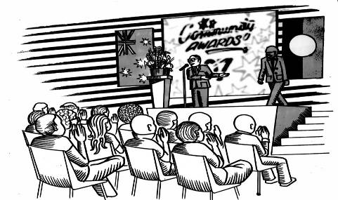

Some important issues to consider when planning the reconciliation event include:
- How does your proposal promote reconciliation in the Australian community?
- How will you consult with local Indigenous peoples when planning your event?
- How will you involve the local Indigenous community in your event?
- Where will you stage the event?
- What form will the event take?
- What special guests have you arranged and why?
- How will you advertise it?
- Will the event be accepted by both the Indigenous community and by the non-Indigenous community? Explain how you could work towards this.
Be creative when planning your event. You could organise:
- an art exhibition which explores ideas about reconciliation
- a sculpture or some other community art project to be installed in your local park or mall
- an Indigenous cultural day, where traditional foods and customs are observed
- a statement about reconciliation which can be displayed in your classroom or school
- a photo collection with images which illustrate important events in the reconciliation process in Australia.

